Steps to navigate to the solution are below, before doing so request you to go through the Solution documentation features implemented section to have good understanding on the implementation.

1. Login to <https://portal.azure.com/>
2. Use the following credentials. **Username**: [ganesan.aiq@outlook.com](mailto:ganesan.aiq@outlook.com) **Password**: Gom40@thi
3. Once that’s done you will be landing in following page

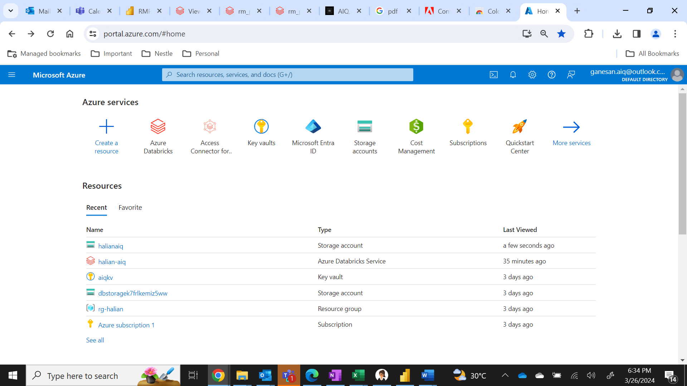

1. In search bar type **storage accounts**

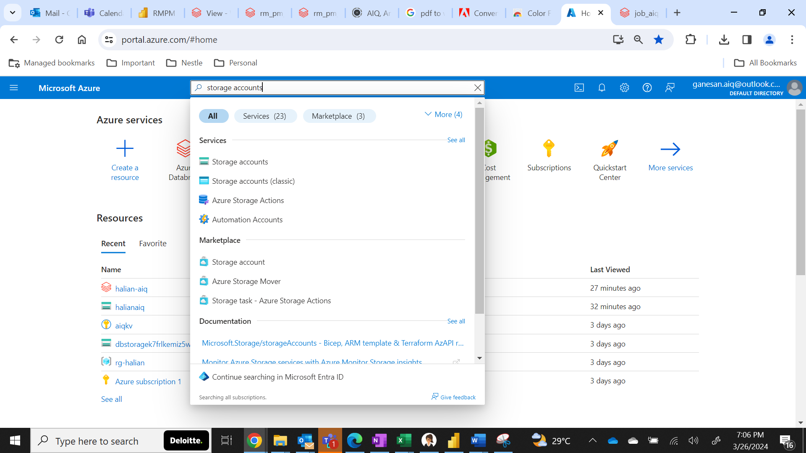

1. Click on the Storage Account



1. Click on the **halianaiq** storage account service.

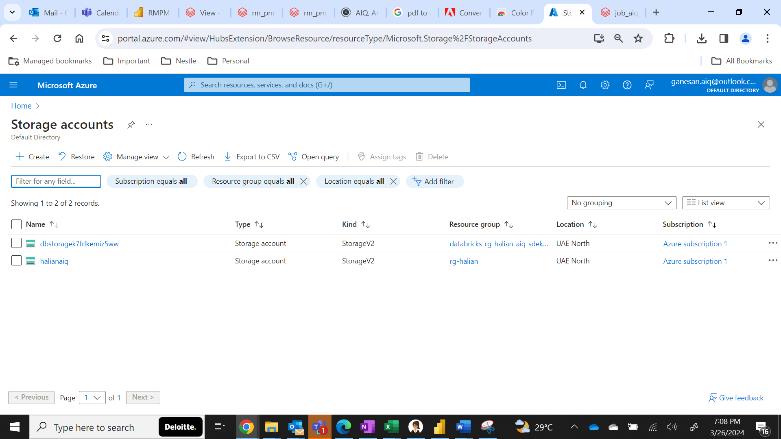

1. Click on the **Containers**.

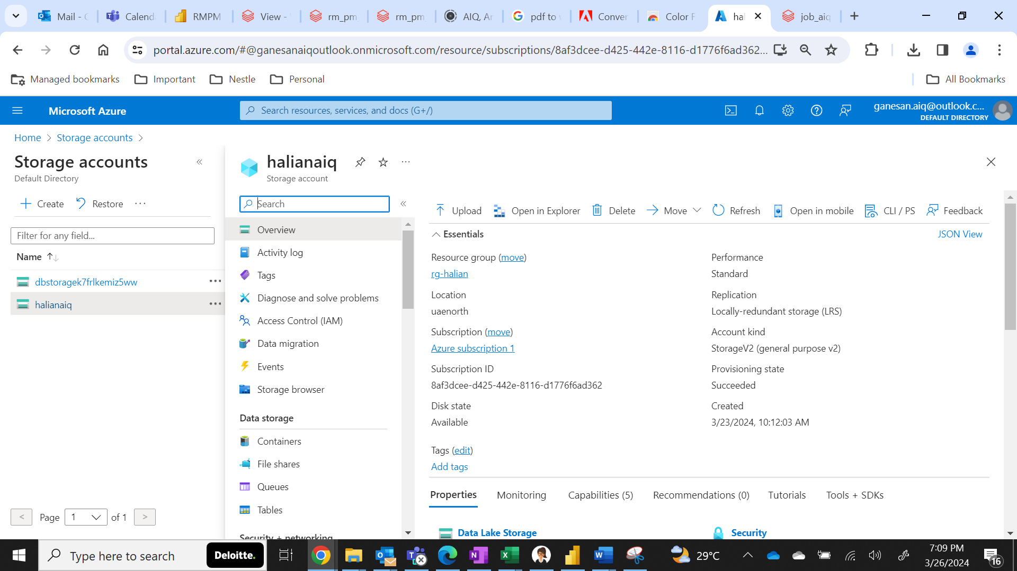

1. Click on **aiq** container.

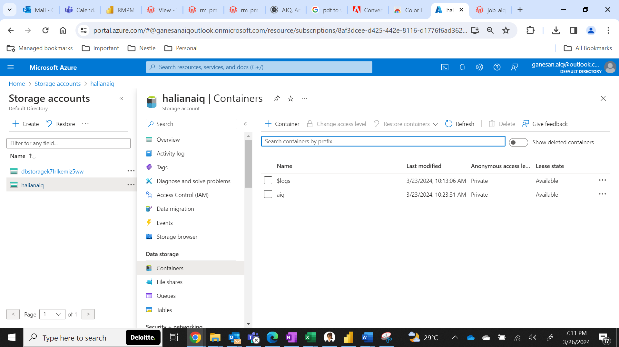

1. It will land in the container and the folders listed in it, click on **inbound** folder.

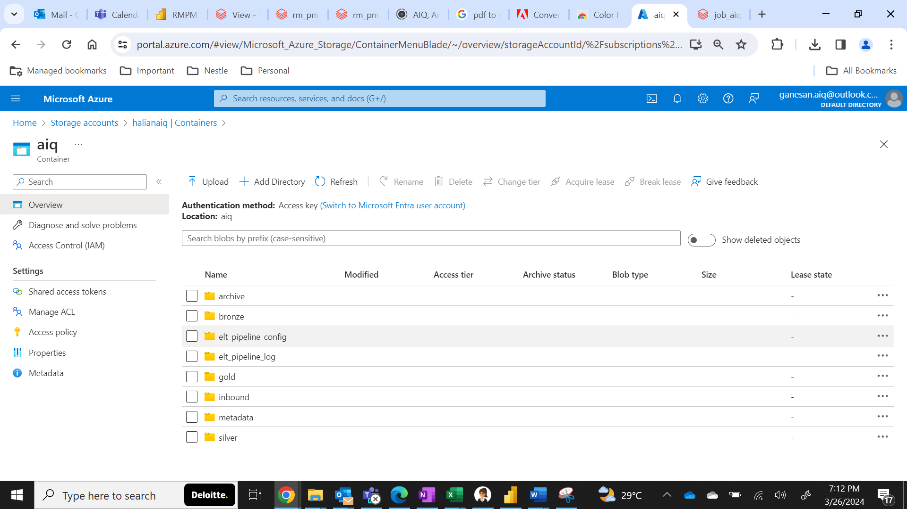

1. Click on the **sales** folder created inside inbound folder.

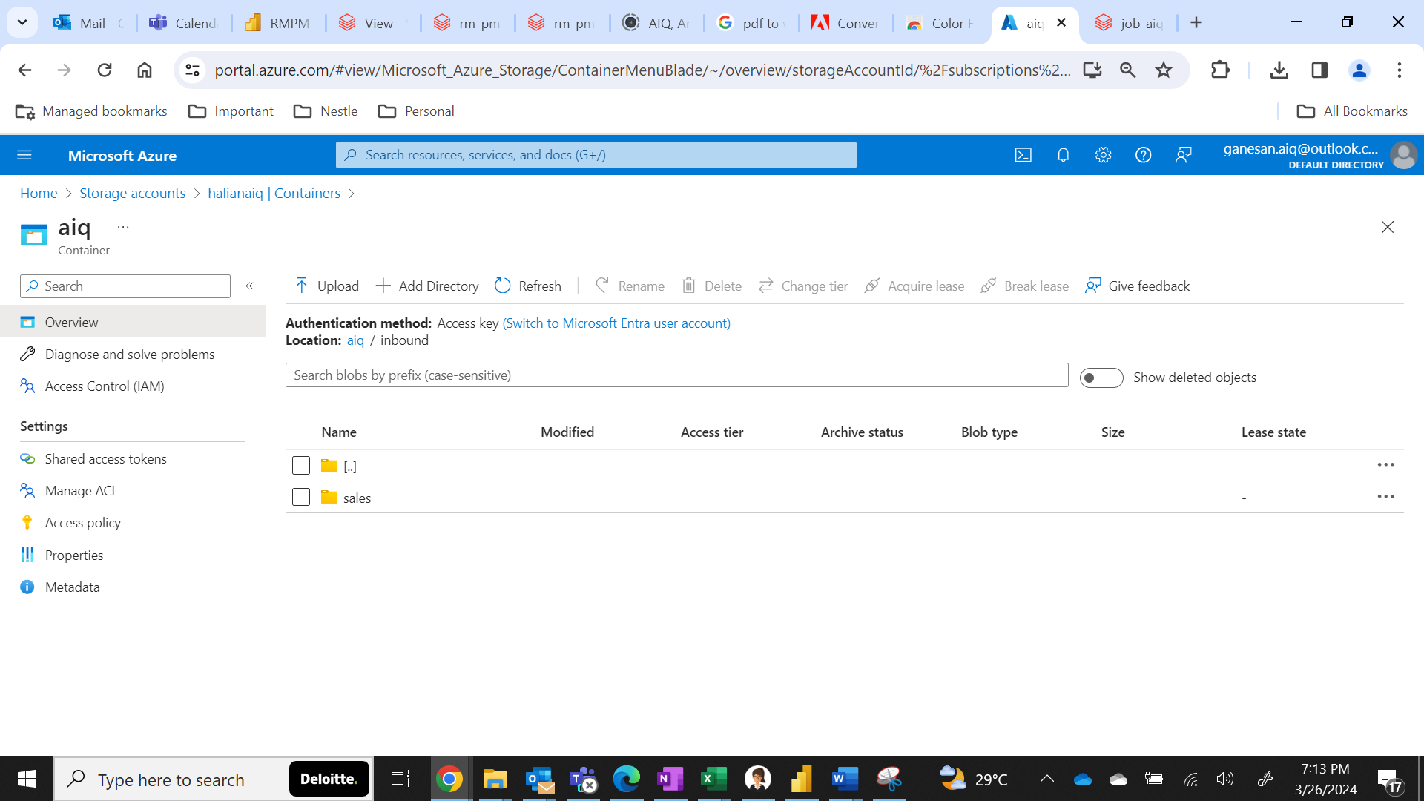

1. Click on the upload once you are inside the sales the browse the sales csv file.

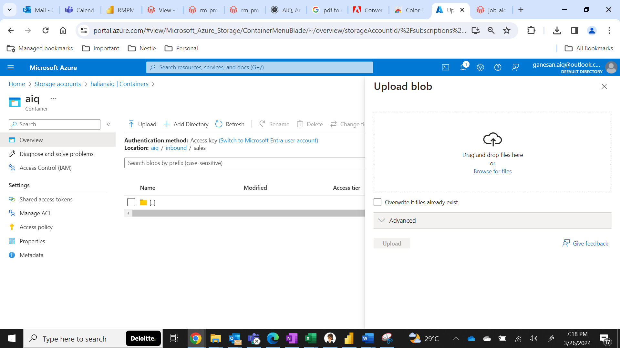

1. Click on the upload option after you browsed.

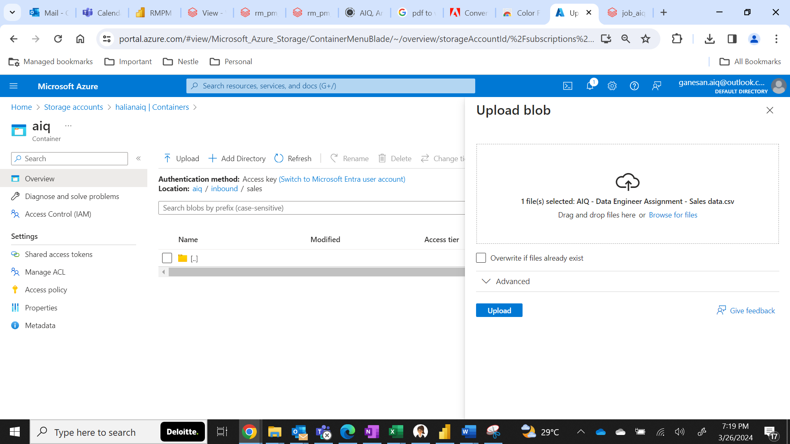

1. Now you will be seeing the file uploaded.

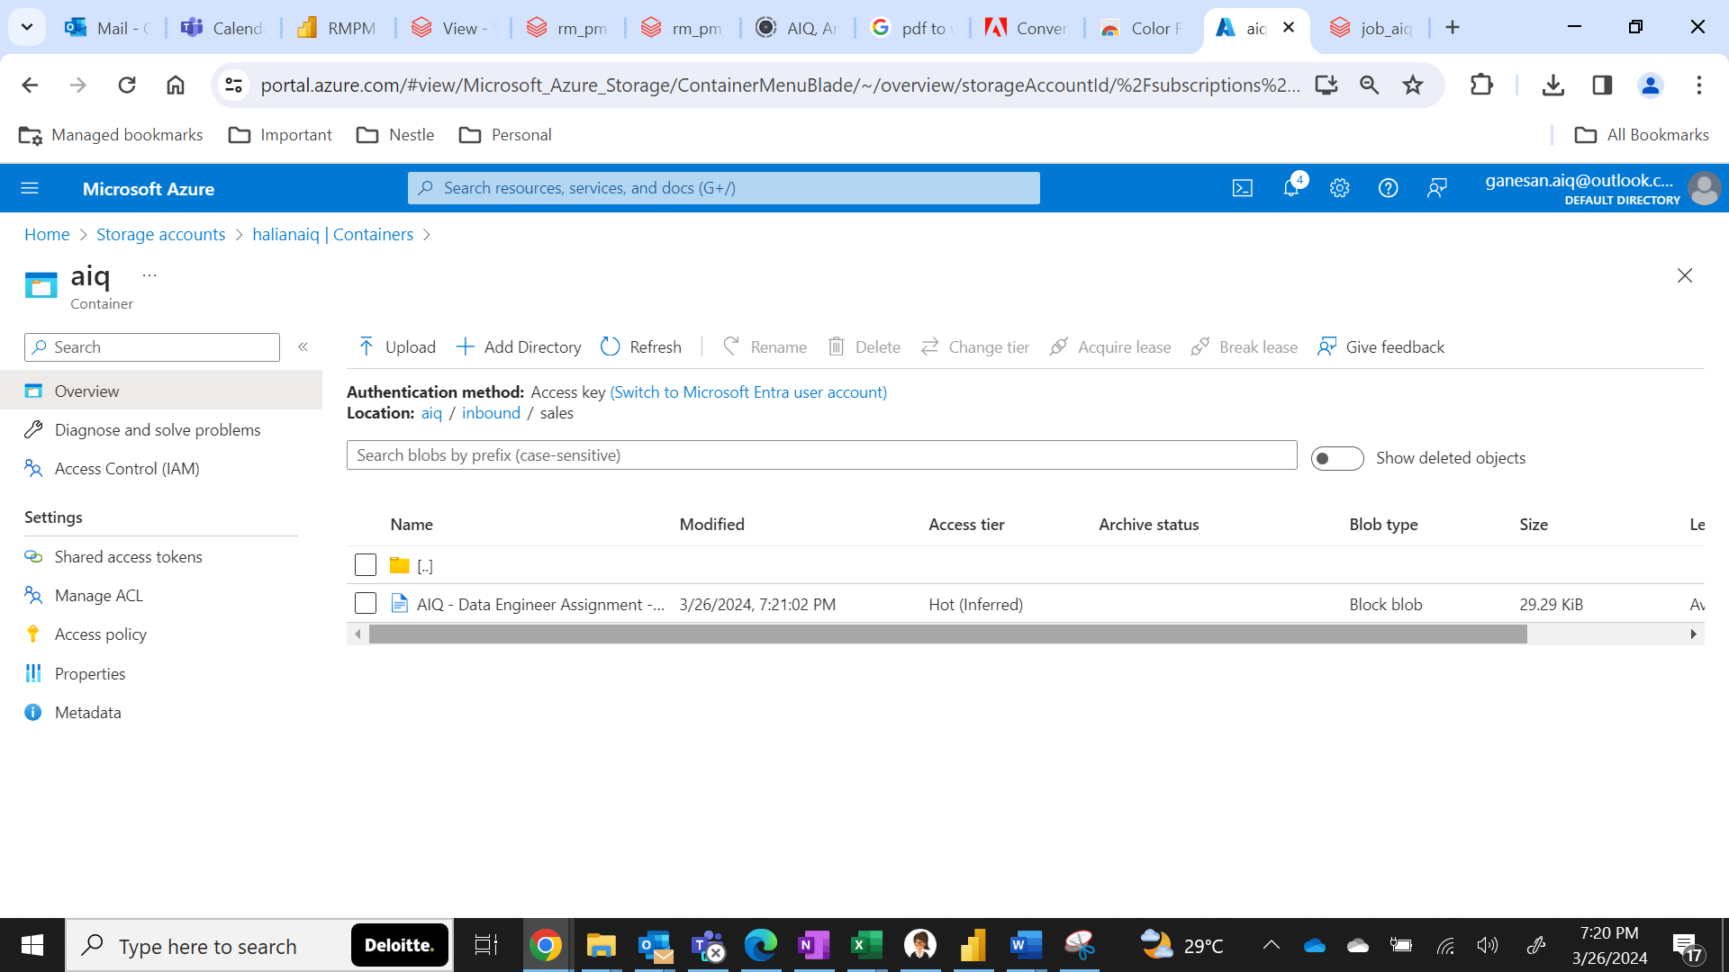

1. In the browser new tab login to <https://portal.azure.com/> using the same credential provided in step 1 go to in the search bar type **azure databricks**

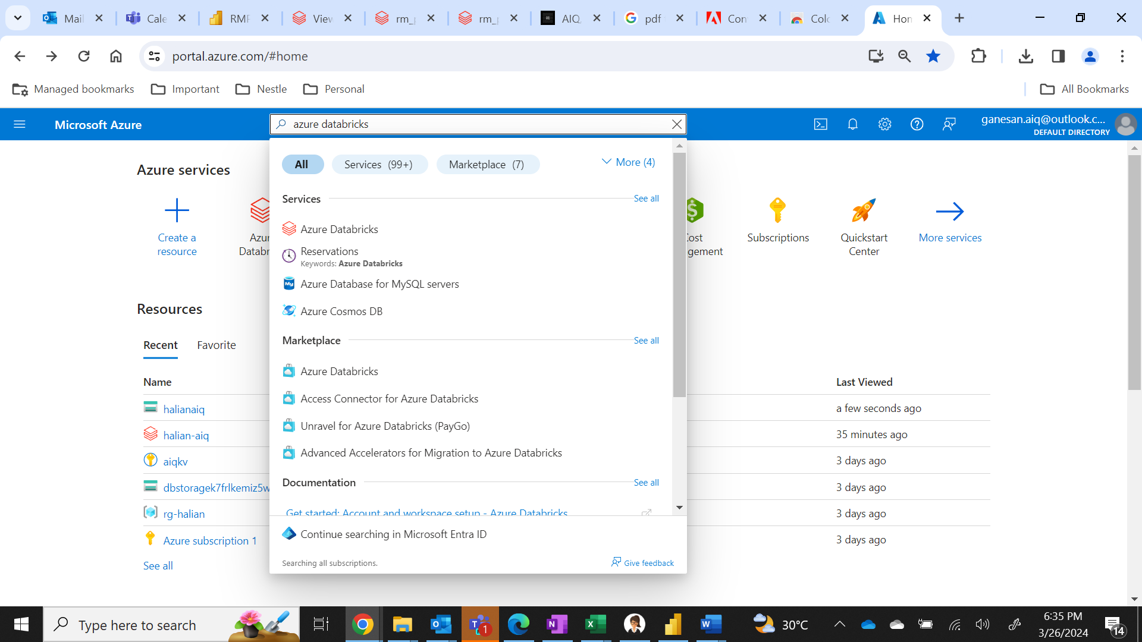

1. Click on the **Azure databricks** option shown in the list.

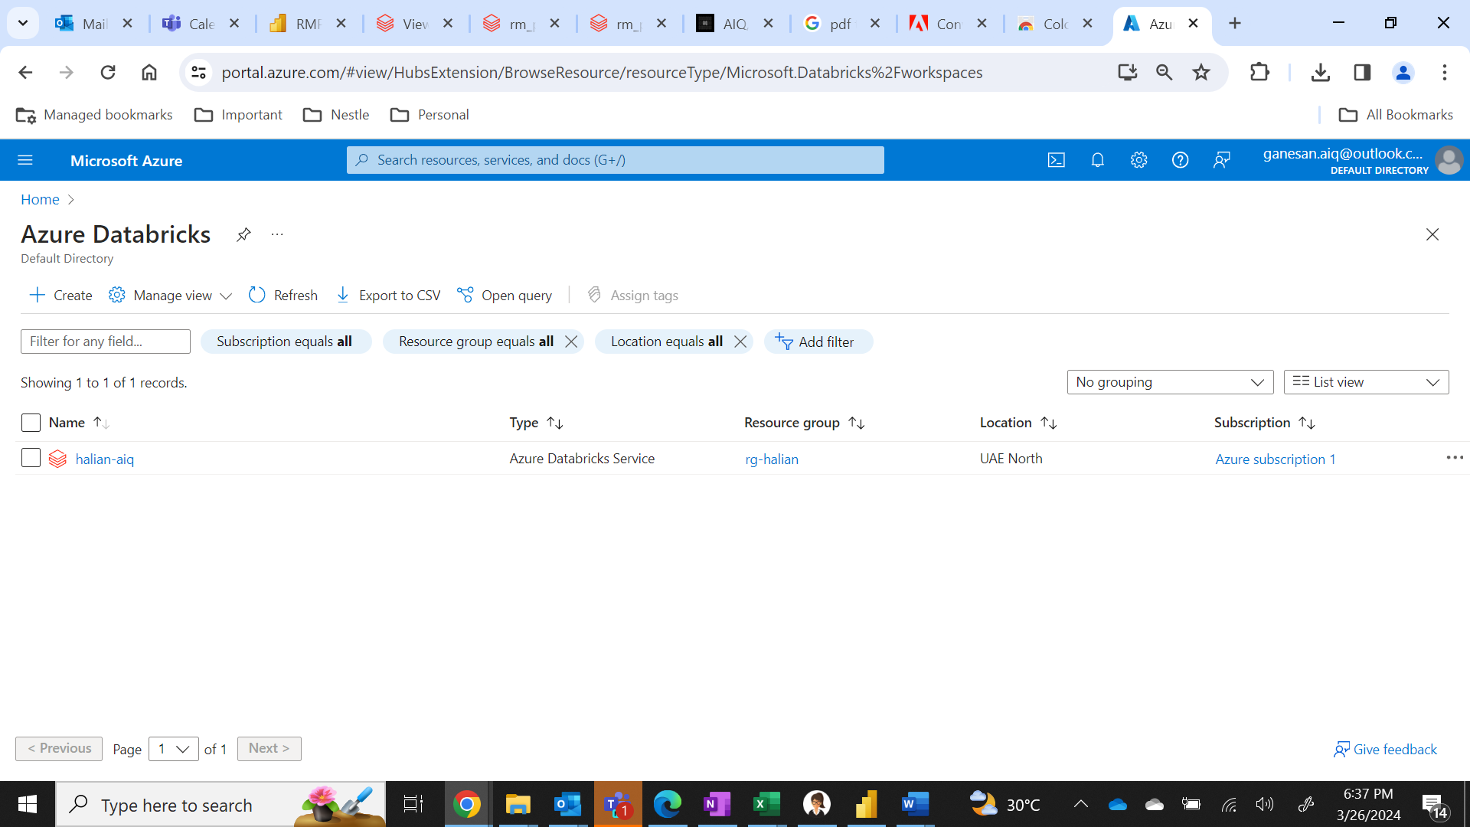

1. Click on the **halian-aiq** service and scroll down to see launch workspace option.

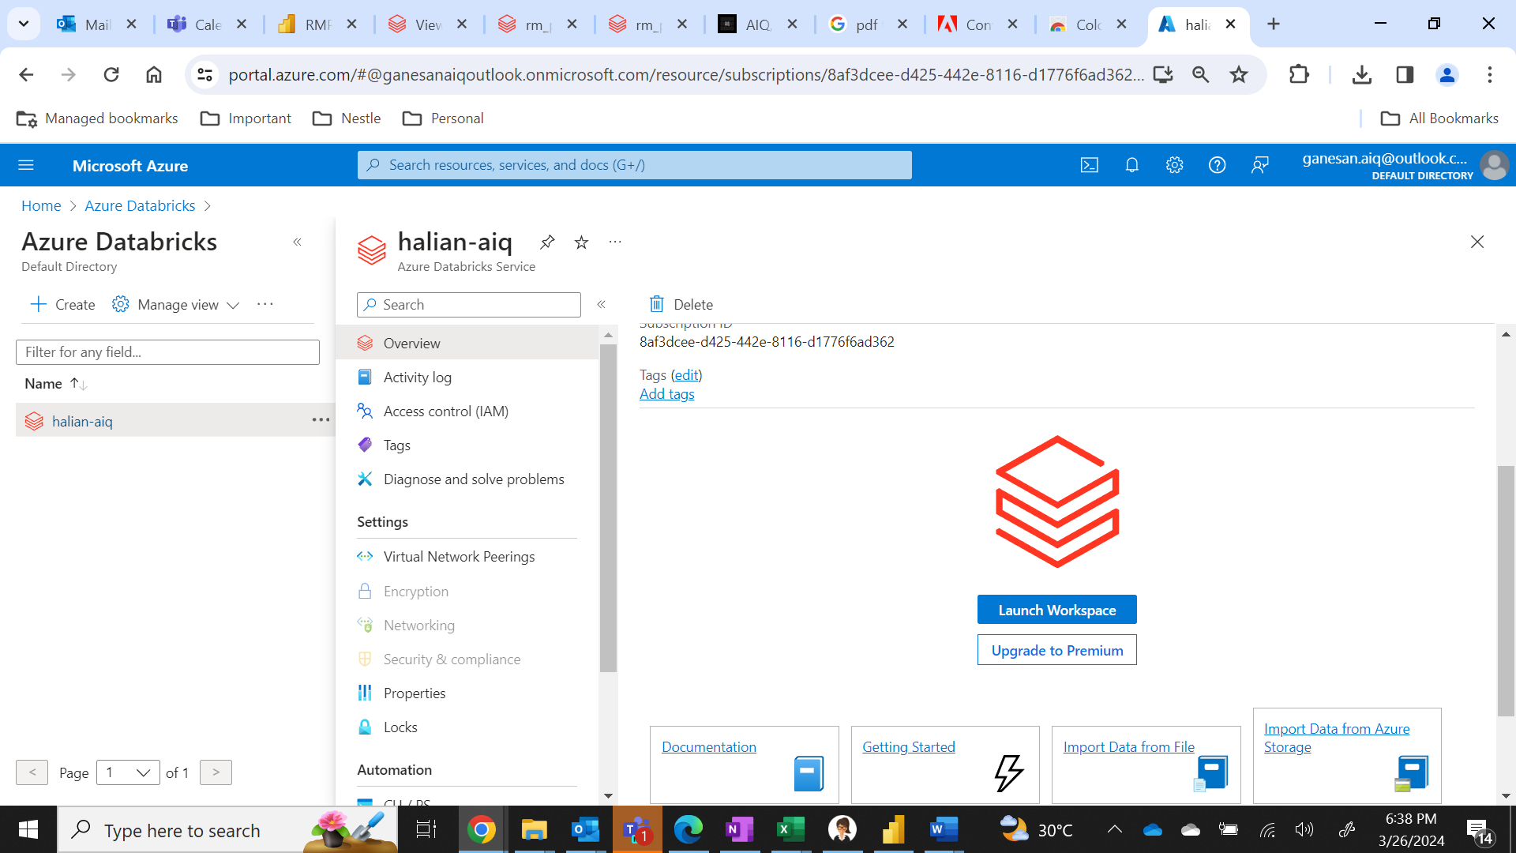

1. Click on **Launch Workspace** as highlighted above then you will see the following page.

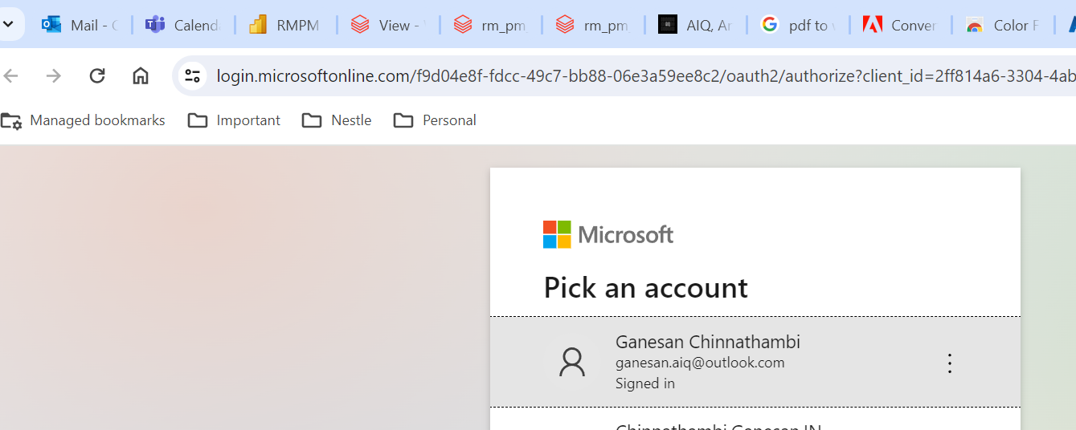

1. Sign in using the same credential provided in step 1, in my case its already signed in as single sign on
2. Once sign in is completed you will be seeing azure databricks home page

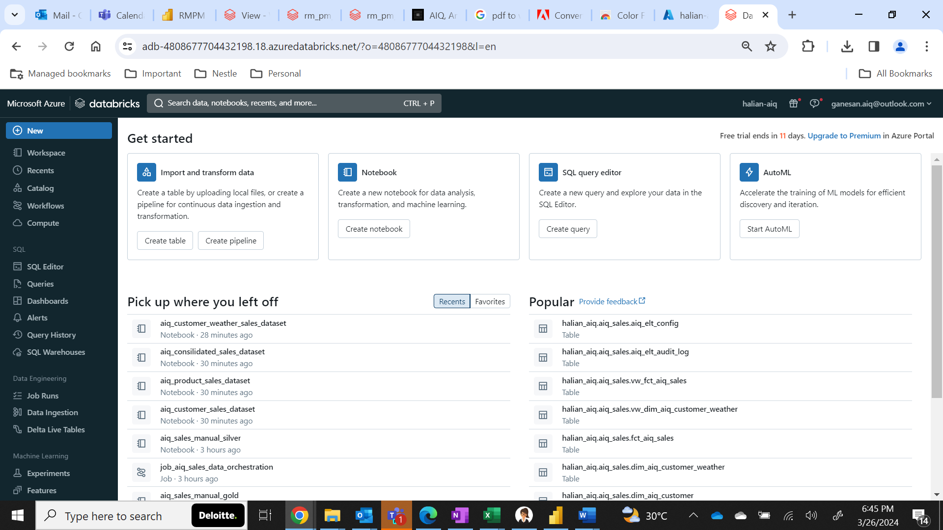

1. In this page navigate to **compute** option

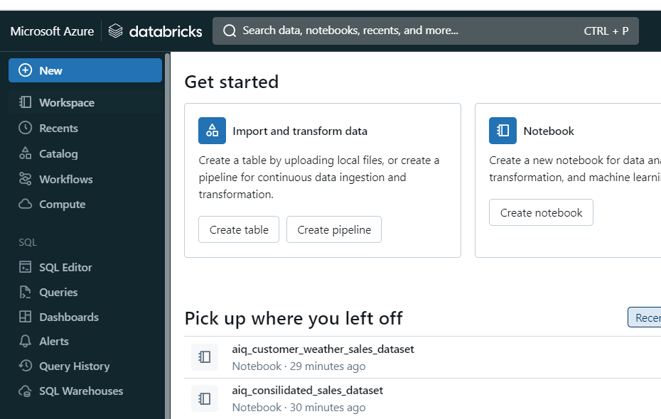

1. You will see the **aiq** cluster created. Click the below **start** icon to start the cluster and wait for the cluster to start (**State 1st column will change as a green tick, see next screenshot for ref**)

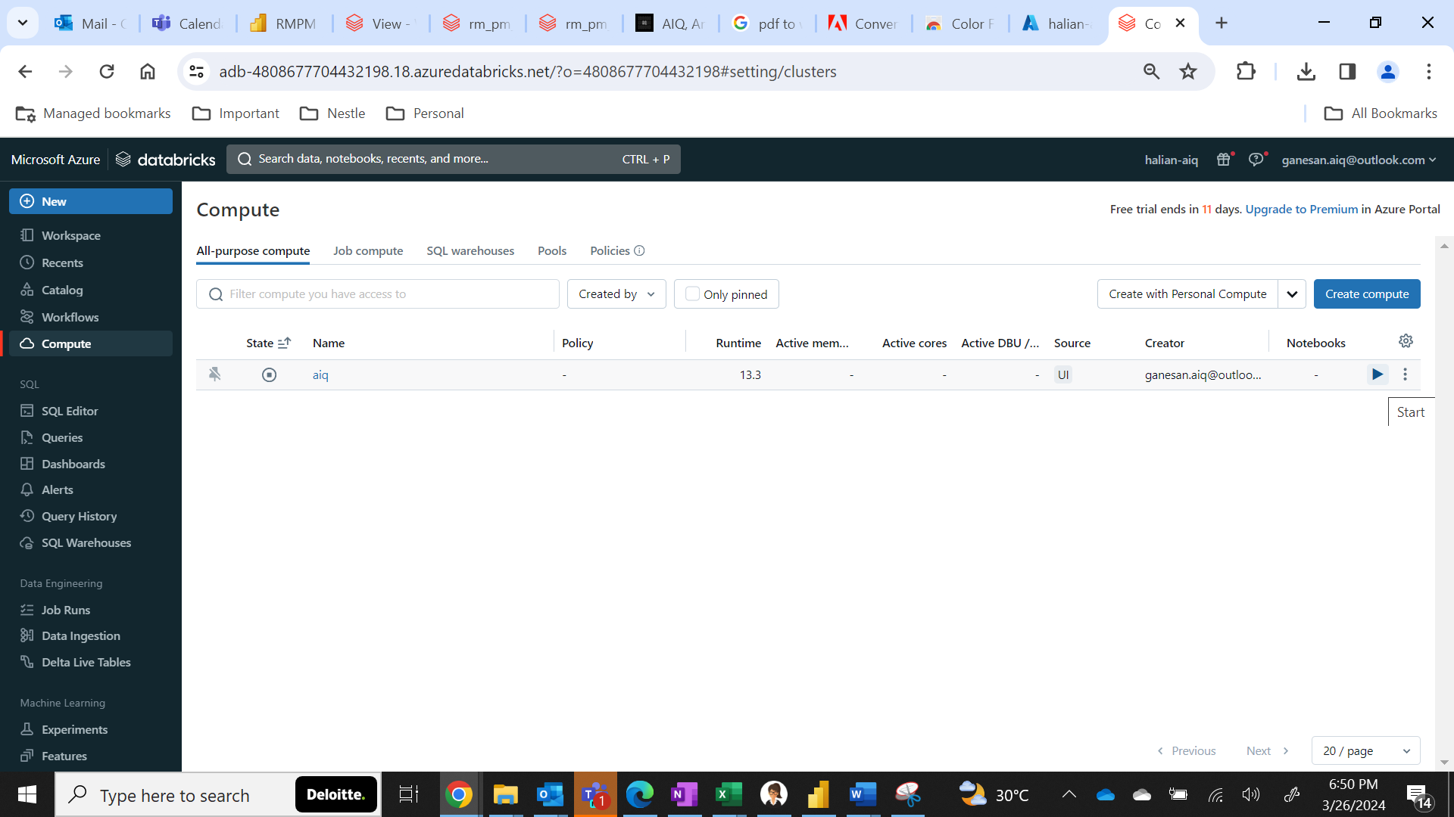

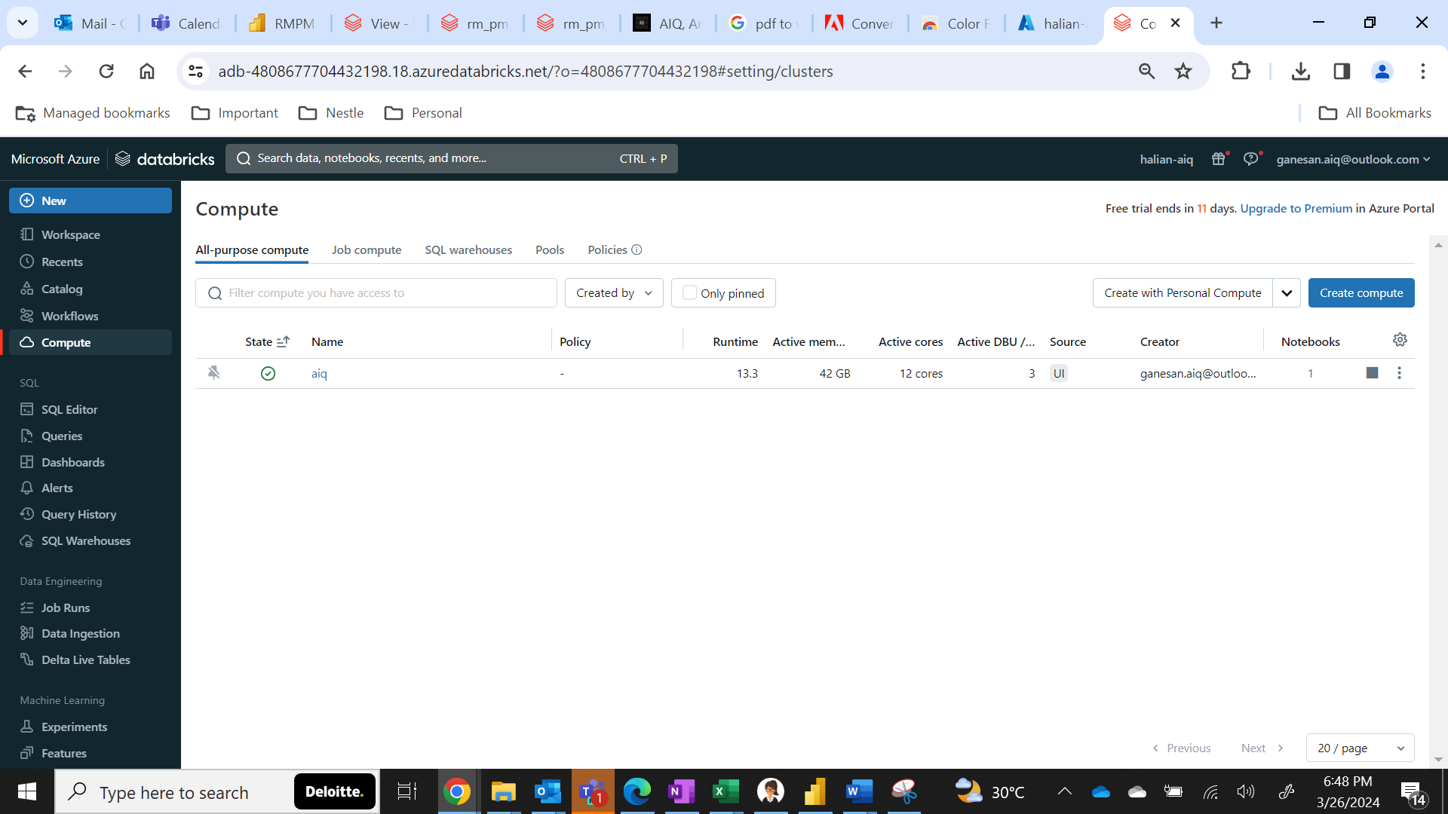

1. Once the cluster is up now navigated to **workflow** option, you will see the **job_aiq_sales_data_orchestration** and click on that job name.

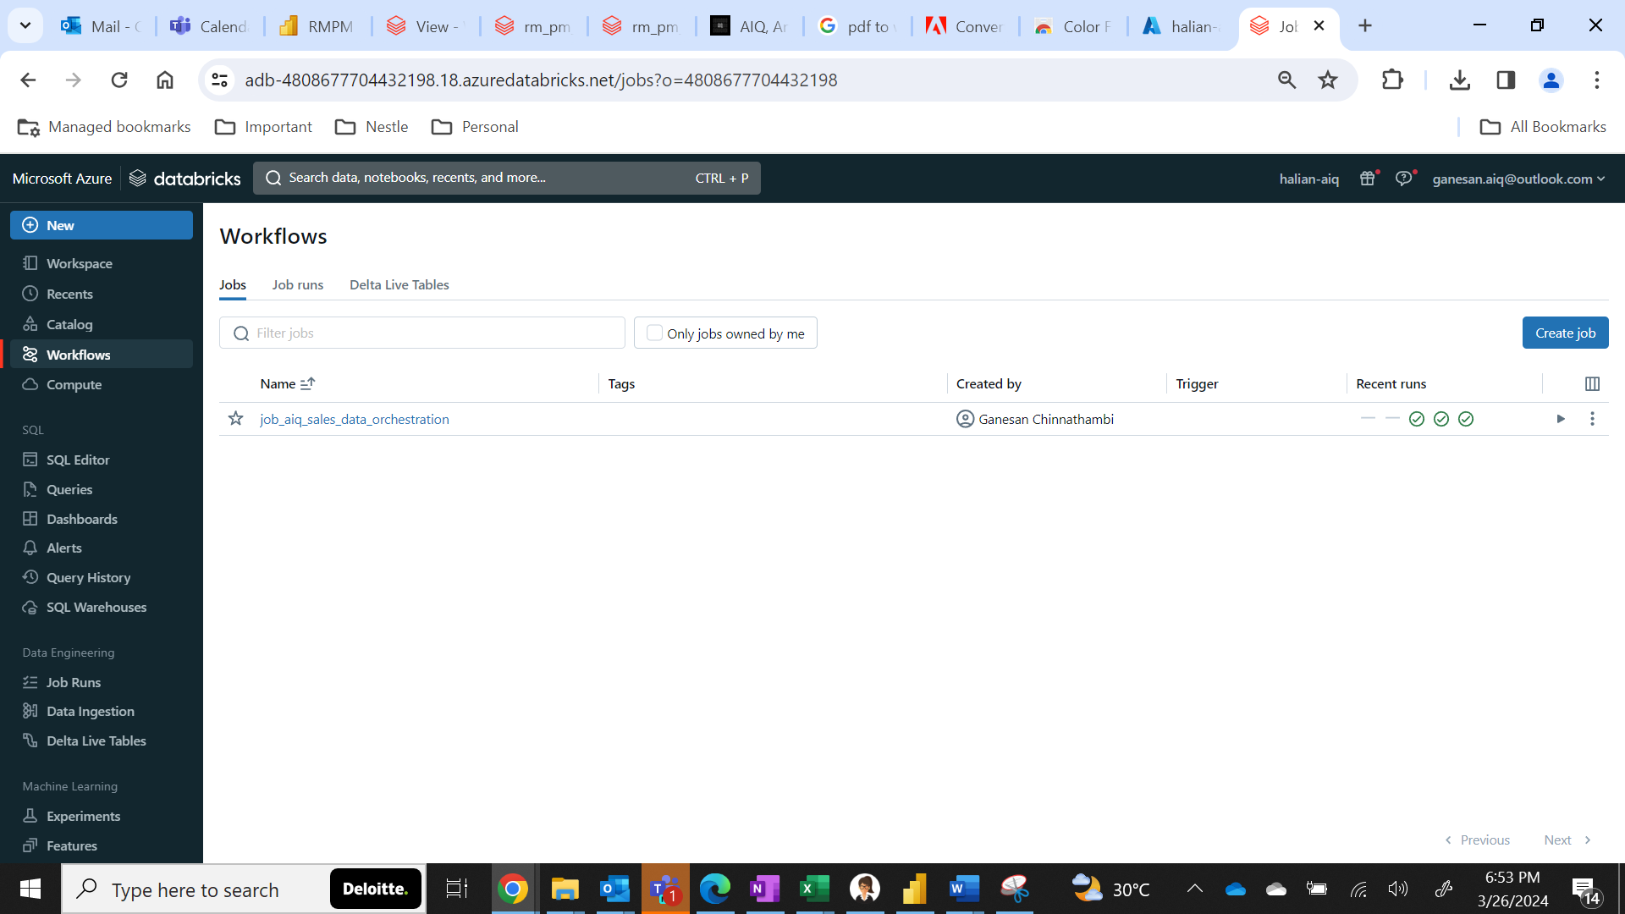

1. Click on the **Run now** option.

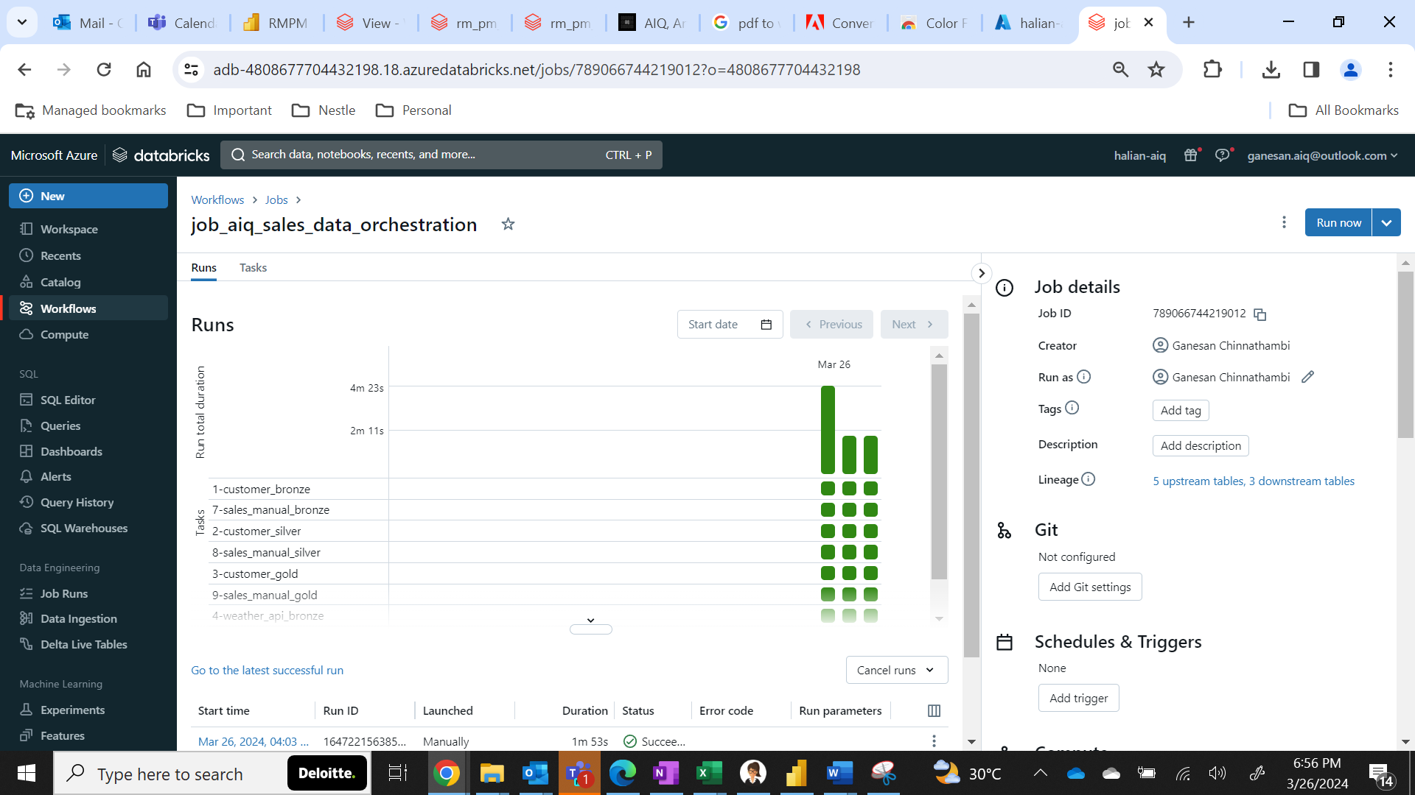

1. Once done you will be able to see the run in the **Runs** pane for each task associated in the job.

**Success** will be indicated in **Green** and Failure will be in red.



1. You can see the tasks in the **Task** pane.

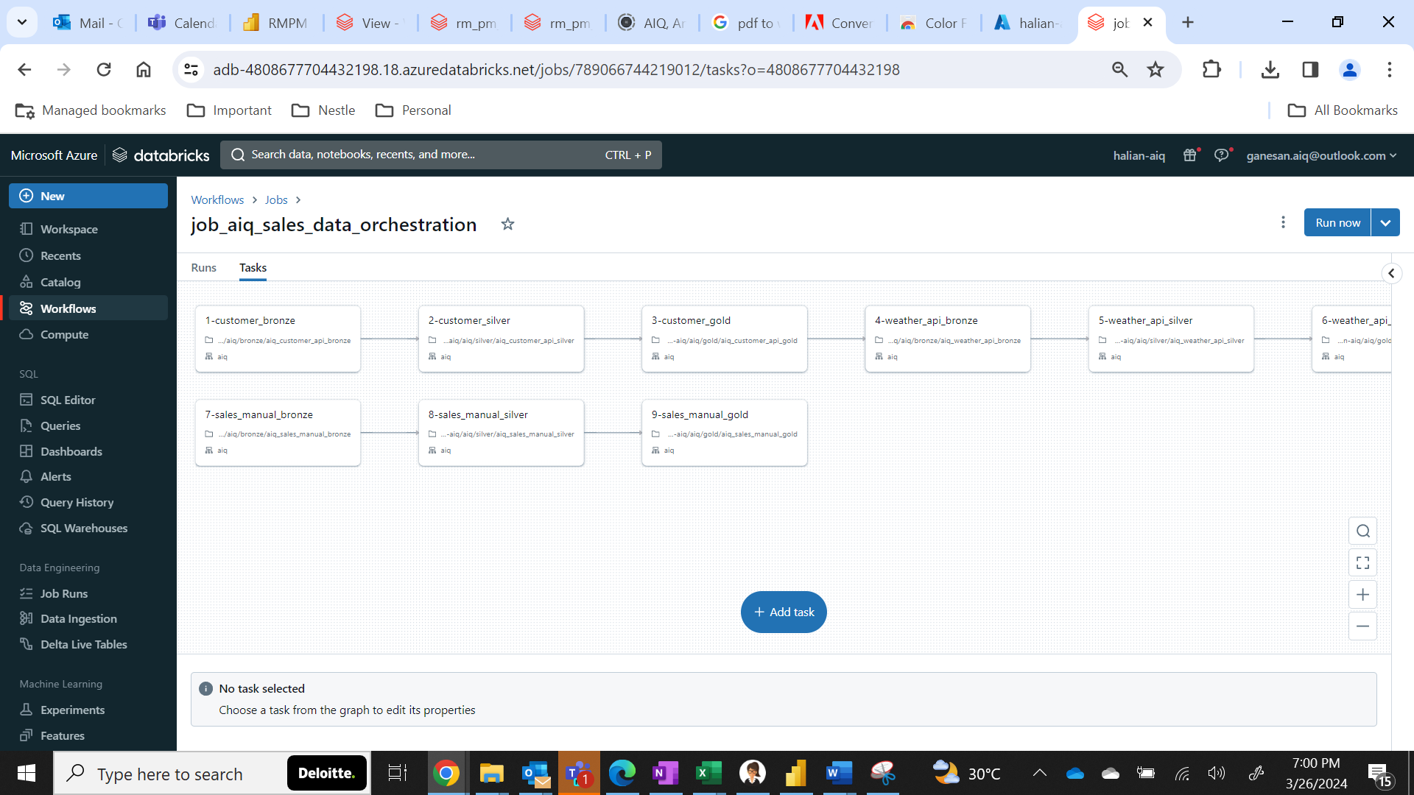

1. Select any task to view its source.

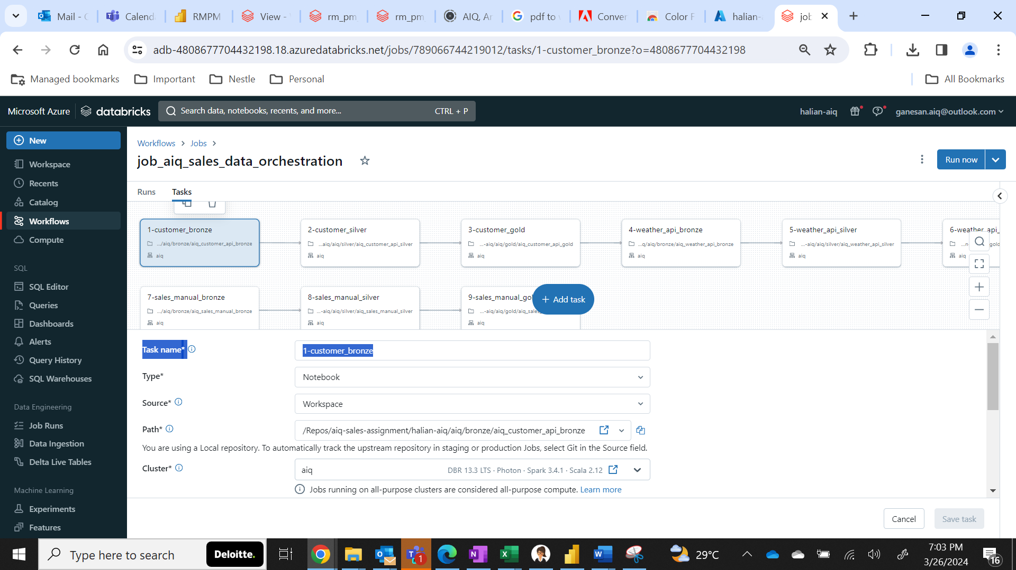

1. Click on the **open icon** in the end of the **path** (notebook selected) to view the source code of the notebook.



Alternatively, it can be viewed in workspace also.

1. Click on **workspace.**

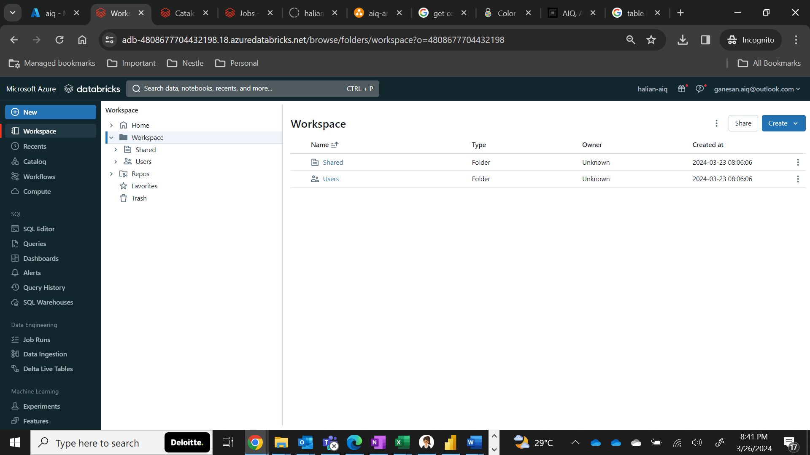

1. Click on **Repos**

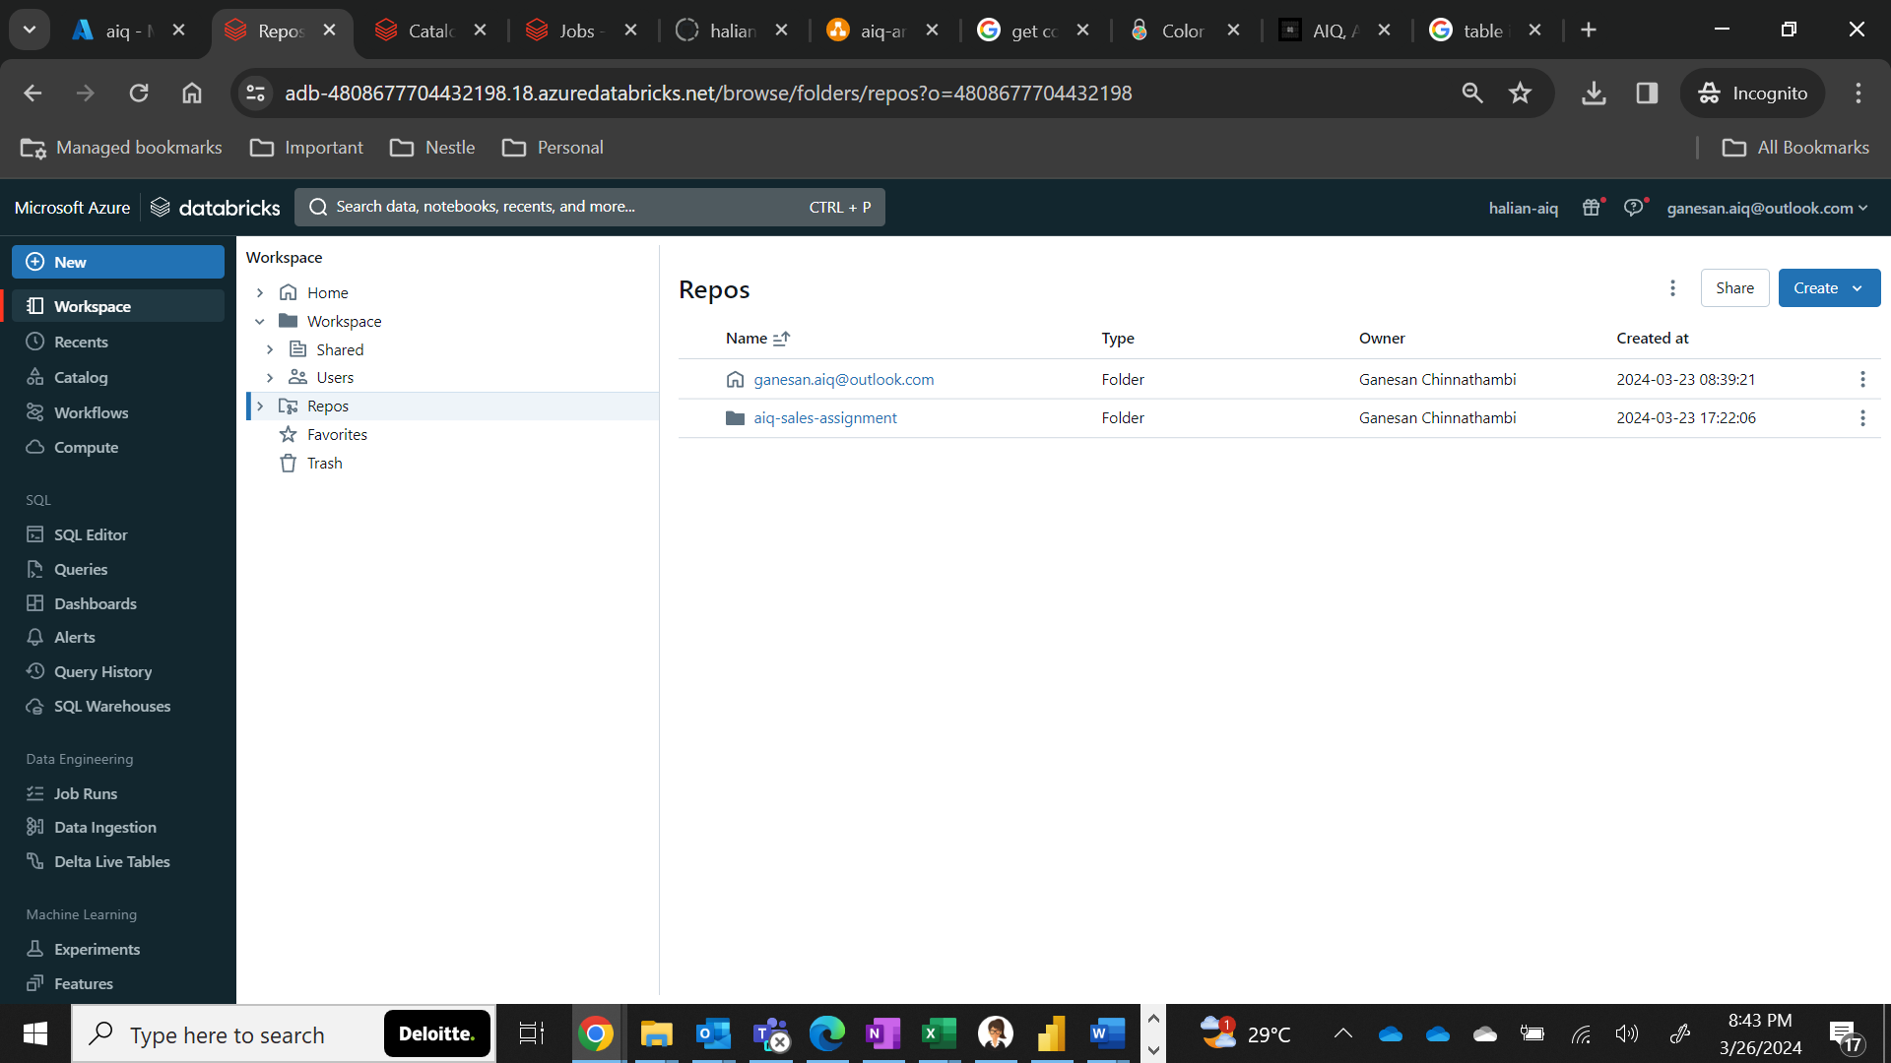

1. Click on **aiq-sales-assignment**

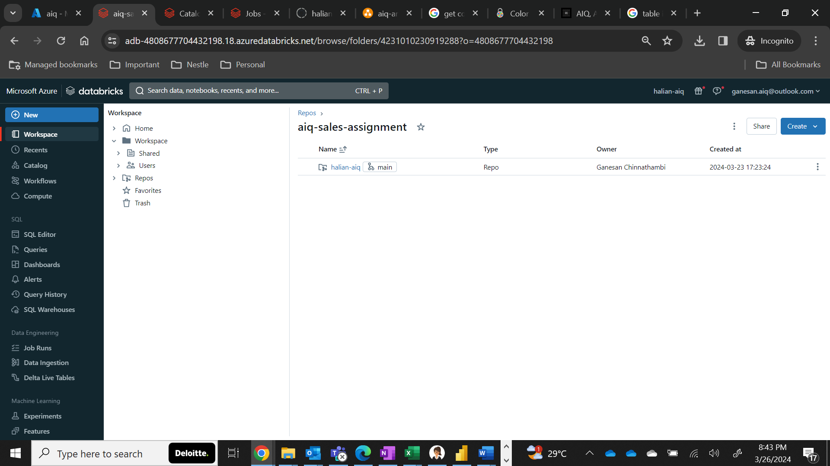

1. Click on the **halian-aiq** repo **(Connected to GitHub)**

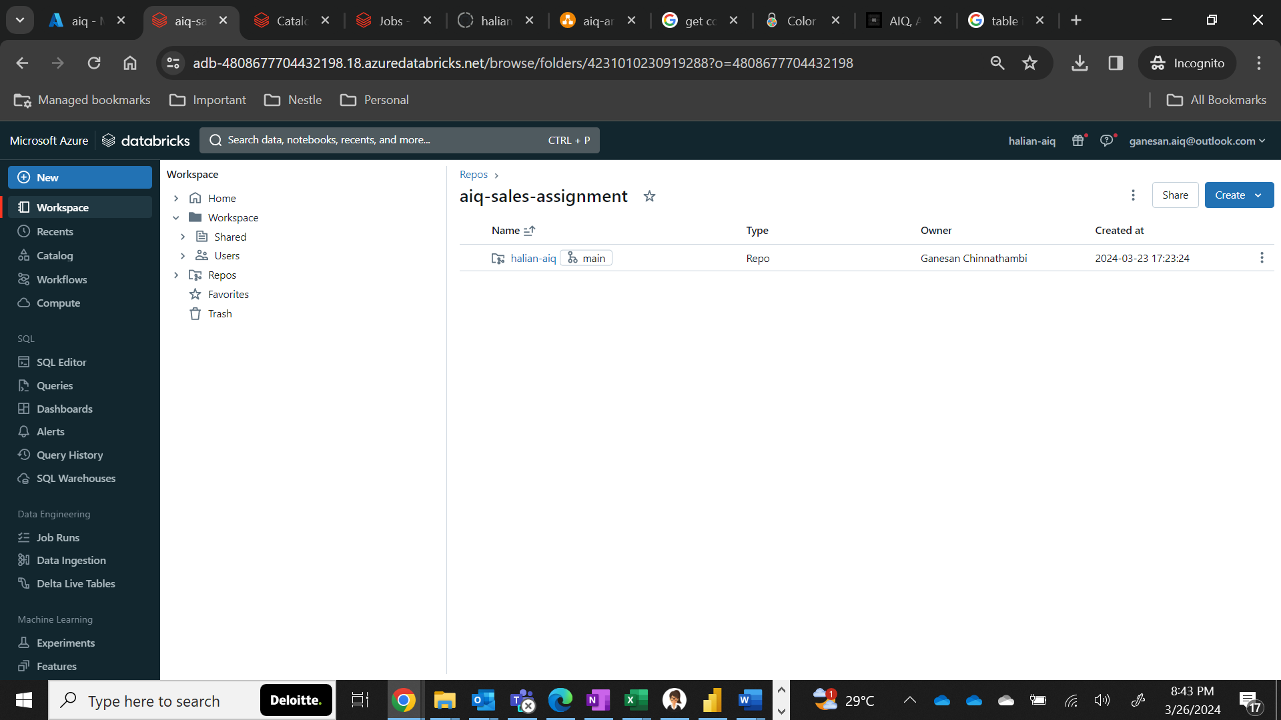

1. Click on **aiq**

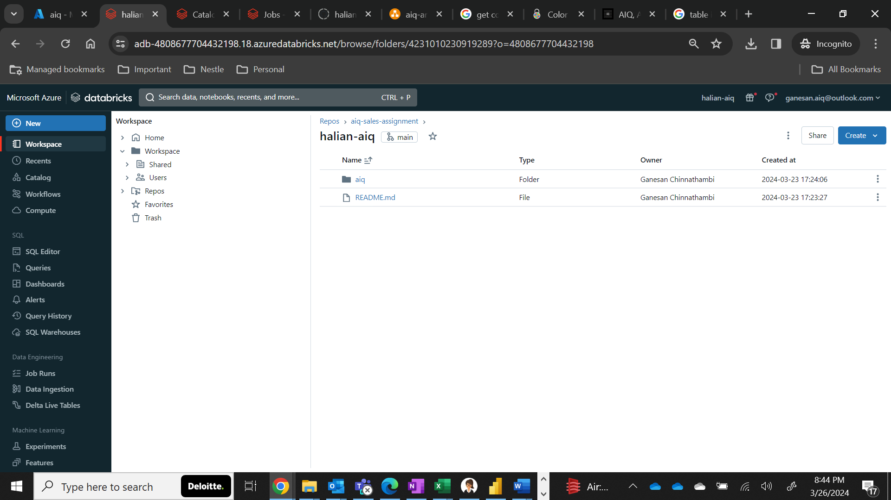

1. You will be able to see all folders used in this entire assignment here.

